1. I have some confusion about bottoms here. (“Do these jeans make my bottom look fat?”)

In the original .R file, the name of the bottom line in original EV files is listed as “1.0 m bottom offset,” which is 1 m up from the “EV bottom pick to edit” line in the original EV files. From the .R file

*# Name of the bottom line in original EV files*

*EVbottom <- TRUE*

*EVbottomname <- "1.0 m bottom offset"*

*# Does the new template include a bottom line? What is it's name?*

*bottomline <- TRUE*

*bottomname <- "EV bottom pick to edit"*

Then the bottom line in the new template is listed as “EV bottom pick to edit,” with the 1.0 m bottom offset being another 1 m off. So that would mean that our new bottom would now be 2 m up from the original EV bottom pick to edit.

Maybe this means that I should list “1.0 m bottom offset” as the bottom name in the .R file for the bottom line in the new template, since this is what is also used in analysis in the template?

I need to look at the original and then the new EV files to compare the bottoms.

Original

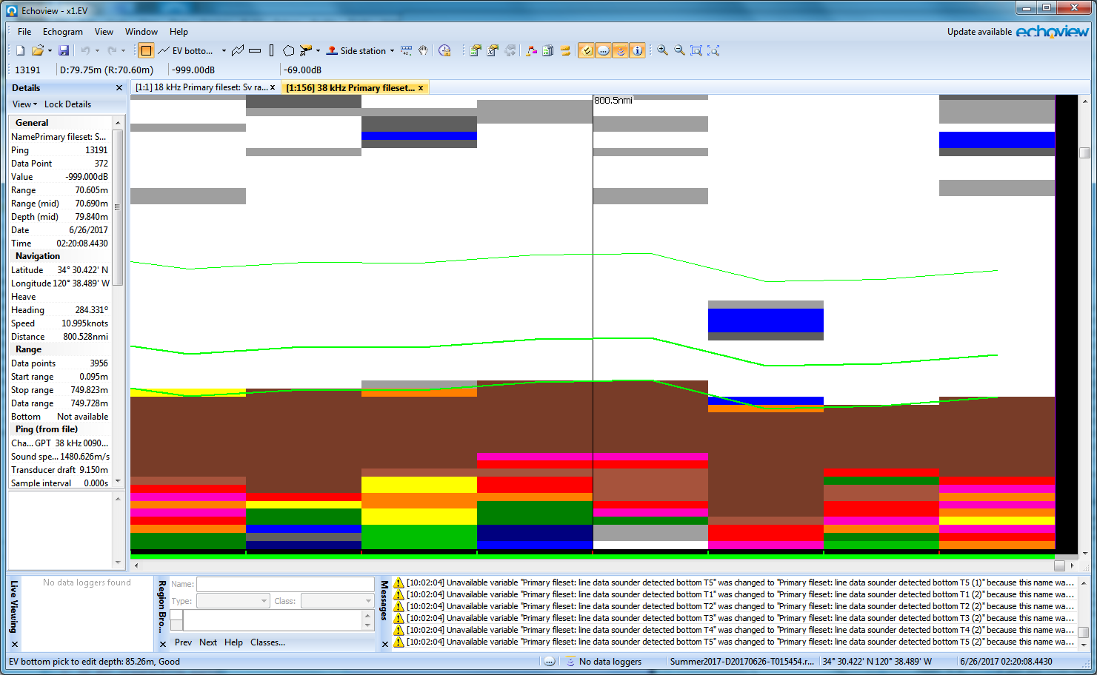

There is an “EV bottom pick to edit” at the bottom, then a 1.0 m bottom offset, then a 3.0 m bottom offset. At the very last ping of the EV file, the “Ev bottom pick to edit” line is at 85.28 m, and the “1.0 m bottom offset” is at 84.28.

In the updated EV file:

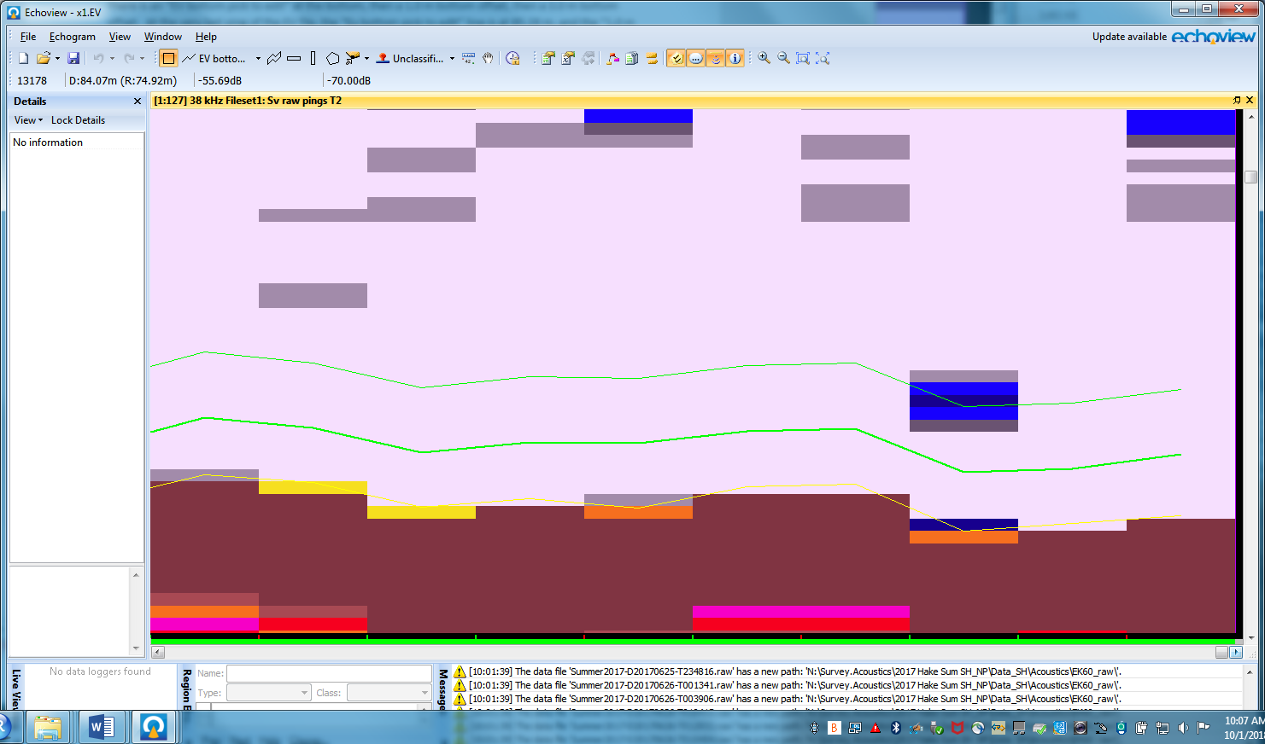

The EV bottom pick to edit line is at 84.28, and the 1.0 m bottom offset is at 83.28. So we have the 1.0 m bottom offset up by 1 m. So perhaps I do need to use “1.0 m bottom offset” as the line in the new EV file

No, if you do that, you can’t overwrite the “1.0 m bottom offset” in the new EV file because it is a virtual line. So, use export the “Ev line pick to edit” from the original EV file, and then use that as the bottom line to overwrite in the new EV file.

1. Also, I am having issues with the bottom line import section (into the new EV) in R

*# Add bottom line and overwrite template bottom line if it exists*

*EVfile$Import(bottomfilename)*

*bottom <- linesObj$FindbyName(paste0("Line",linenum+1))*

*linenum <- linenum + 1*

*if(bottomline == TRUE){*

*oldbottom <- linesObj$FindbyName(bottomname)*

*oldbottom$OverwriteWith(bottom)*

*linesObj$Delete(bottom)*

*} else if(bottomline == FALSE){*

*bottom[["Name"]] <- "Bottom"*

When I try to run this, I get an error that there is no line3 in the Echoview file. And there isn’t, and I don’t know if I should put one in the template? I don’t remember doing that before, so I am completely confused as to why I could get the scripts to run before but can’t now. I tried adding a “line3” to the template, but then it knows the line is there and counts it in the total number of lines, and then it can’t find line4.

I am wondering if in previous versions of Echoview, that line was always just imported as the next line number up, but now it is imported as the name of the file (e.g. x1 (before the .bottom.evl). This is what the imported bottom line is called in x1. So I have changed this portion of the .R file to be

*# Add bottom line and overwrite template bottom line if it exists*

*EVfile$Import(bottomfilename)*

*#bottom <- linesObj$FindbyName(paste0("Line",linenum+1))*

*#this doesn't work anymore, because it's not coming in as the name of the next line*

*bottom<-linesObj$FindbyName(name) #Add this instead - looks like the name of the line comes from the filename*

*linenum <- linenum + 1*

*if(bottomline == TRUE){*

*oldbottom <- linesObj$FindbyName(bottomname)*

*oldbottom$OverwriteWith(bottom)*

*linesObj$Delete(bottom)*

*} else if(bottomline == FALSE){*

*bottom[["Name"]] <- "Bottom"*

*}*

This seems to work now, so issue 2 is resolved.